I can describe the role of Georgia in World War II.
- Describe the key events leading up to American involvement in World War II; include the Lend-Lease Act and the bombing of Pearl Harbor.
- Evaluate the purpose and economic impact of the Bell Bomber plant, military bases, and the Savannah and Brunswick shipyards.
- Explain the economic and military contributions of Richard Russell and Carl Vinson.

SS8H9 Describe the role of Georgia in World War II.

Summary
World War II was fought between the Axis Powers (Germany, Italy, Japan) and the Allied Powers (Britain, United States, Soviet Union, France). Most of the countries in the world were involved in some way. It was the deadliest war in all of human history. Around 70 million people were killed.

World War II started in 1939 when Germany invaded Poland. Great Britain and France responded by declaring war on Germany. World War II started in Europe, but spread throughout the world. Much of the fighting took place in Europe and in Southeast Asia (Pacific).
The war in Europe ended with Germany’s surrender on May 7, 1945. The war in the Pacific ended when Japan surrendered on September 2, 1945.

Lend-Lease Act
When World War II began in September 1939, many Americans saw it as a “European” problem and hoped to stay out of the conflict. As Germany continued to be victorious and take over nation after nation, the U.S. continued to watch from the sidelines. In the Pacific, Japan was taking over large portions of China and other countries of Southeast Asia, and the U.S. continued to remain neutral.
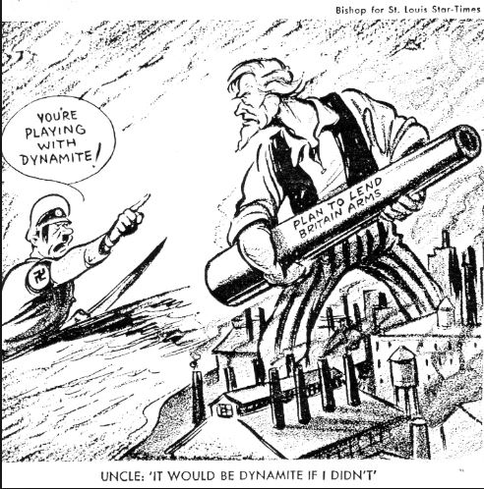
Though America officially stayed out of the fight until December 7, 1941, President Roosevelt and the U.S. Congress were anything but neutral. Fearing a victory by Japan and Germany, the U.S. lent support to allies who were at war with the Japanese and the Germans. The U.S. sent billions of dollars in supplies to the United Kingdom, France, the Soviet Union, and China. In exchange, these allied countries gave the U.S. the privilege to use military bases in their countries if necessary. The Lend-Lease Act was passed by Congress in February of 1941 and signed into law by Roosevelt in March.

The Lend-Lease Act was an act that allowed the U.S. government to send billions of dollars in supplies and military equipment to allied countries in exchange for U.S. rights in their military bases. For the next four years, the U.S. continued to supply the countries supplies and military equipment while taking part in the war as well. Though there was considerable opposition to the Lend-Lease Act by opponents of war, this program successfully helped Great Britain defend against German invasion.

Pearl Harbor
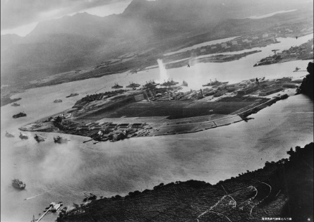
One of the most tragic events in America’s history was the Japanese surprise attack on the Navy base in Pearl Harbor, Hawaii. Pearl Harbor was an American Naval base in Hawaii. A surprise attack on the base by Japanese forces on December 7, 1941 resulted in the U.S. entering World War II. On December 7, 1941, over 300 Japanese planes attacked Pearl Harbor in hopes of crippling the U.S. military in order to further their plan to take over more land in the Pacific. In the attack, over 2000 Americans were killed and the U.S. lost over 150 ships.

While the attack accomplished its goal of damaging the U.S. Navy, it also changed the vast majority of opinions about staying out of the war. On December 8, 1941, in a moving speech, President Roosevelt called December 7, “a day that will live in infamy” and asked Congress to declare war on Japan, which it did. A few days later, Germany and Italy declared war on the U.S., which America responded in turn. From December 8, 1941, until victory in 1945, America fought a two- front war against Japan, Germany, and Italy.

Georgia’s Role
Georgia played a key role in providing military support to the war effort. Georgians built aircraft and Liberty ships. The state also trained many members of the infantry. Georgia’s participation in the war effort was essential to the allied success of World War II.

Bell Bomber Plant
The Bell Bomber plant in Marietta, Georgia was important for the production of the B-29 bomber (a type of airplane that drops bombs). This bomber was America’s most technologically advanced bomber during World War II. The Bell Bomber plant was able to produce over 650 of the bombers before the end of World War II. The U.S. used these bombers in World War II and later in the Korean War.
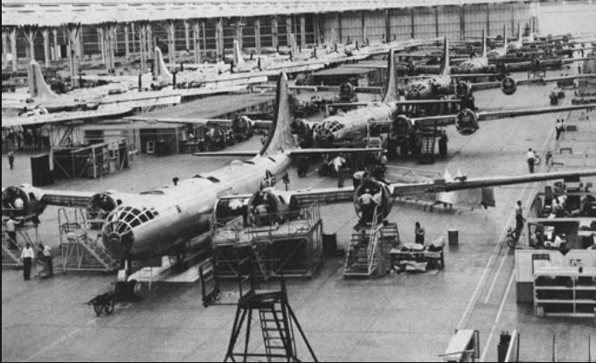
The Bell Bomber company had an even more important impact on the economy of Georgia. During the war, almost 30,000 people—many from Georgia—were employed at the Bell Bomber Plant. This was the largest plant to have ever been built in the Deep South. The Dobbins Air Force Base was located near the Bell Bomber Plant. This added more employment opportunities for Georgians.

After the war, the Bell Bomber plant closed until 1951. The Lockheed Martin Company took over the facility. Today, Lockheed Martin continues to employ many Georgians.

Military Facilities
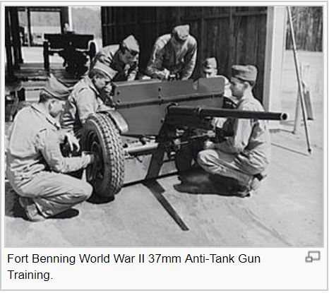
During World War I, there were more military facilities in Georgia than any other state. During World War II, many of these bases grew in size. They played an important role in training and supplying the military during the war. For example, Fort Benning near Columbus, Georgia, was the largest and was thought of as the best infantry facility during the war. Interestingly, these bases also held thousands of enemy prisoners (Prisoners of War/POWs). Today, these bases provide thousands of jobs for Georgians and pump millions of dollars into the state’s economy.

Liberty Ships
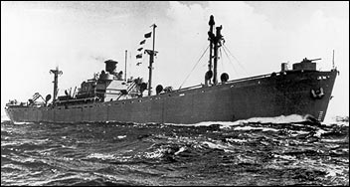
A major contribution during the war came from the large number of civilians (many of whom were women) who built liberty ships during the war. These ships were used to transport troops and supplies to both the European and Pacific fronts. A total of 187 ships used during the war were built in either Savannah or Brunswick.

The economic impact of the Savannah and Brunswick shipyards on Georgia communities was huge. More than 15,000 employees, many of which were women, built 88 Liberty ships at the Savannah shipyard. The J. A. Jones shipyard in Brunswick turned out 99 Liberty ships in just two years. Local economies were boosted when thousands of Georgia citizens earned paychecks that were ultimately re-invested in community businesses.

Richard B. Russell
Richard B. Russell, Jr. (1897-1971) was a governor of Georgia and U.S Senator, serving in the Senate for 38 years. At the age of 23, he was one of the youngest people ever elected to the Georgia General Assembly. In 1931, Russell was elected Governor of Georgia. He was the youngest Georgia Governor in the 20th century. Russell didn’t serve as a Governor for very long because he became Senator.

Russell played a major role as a U.S. Senator from Georgia. While Russell served on multiple committees, he became very influential in U.S. military policy. Russell was an advocate for a strong military during the 1930s. He helped the U.S. prepare to fight in World War II. He was also influential in bringing or maintaining 15 military bases in the state, along with many other research facilities, including the Centers for Disease Control.

Richard B. Russell was a strong segregationist. He opposed many civil rights bills during his career.

Carl Vinson
Carl Vinson (1883-1981) is often quoted as saying, “The most expensive thing in the world is a cheap Army and Navy.” In his 51 years in the U.S. House of Representatives (the longest in U.S. history), Vinson made it his mission to make certain that the U.S. spent funds on both, especially the Navy. Carl Vinson is best known as the “Father of the Two Ocean Navy.”

Carl Vinson earned his nickname, the Admiral, due to his advocacy for a strong Navy during the 1920s and 1930s. During the 1920s, most people ignored his calls to strengthen the U.S. military. Due to his hard work for over 50 years, Vinson received the Presidential Medal of Freedom and had a U.S. nuclear powered aircraft carrier named after him.

Vinson’s insistence on developing and maintaining a strong Army and Navy had a huge economic impact on many communities. Before the Japanese attack on Pearl Harbor, Vinson pushed through Congress two bills to expand naval aviation by building 10,000 plane, the training of 16,000 pilots, and the establishment of 20 air bases. He also oversaw the construction of naval facilities.

The economic impact on Georgia—especially coastal Georgia—during World War II was evident. Over 90% of the workforce on Georgia military installations were civilians. Over 20,000 jobs were brought to local communities. Throughout his congressional career (the longest of any person serving in Congress), Carl Vinson was loyal to providing U. S. military support in Georgia and throughout the nation and world.

