I can describe Georgia’s contributions to World War I.
b. Explain economic factors that resulted in the Great Depression. (e.g., boll weevil and drought).
c. Describe Eugene Talmadge’s opposition to the New Deal Programs.
d. Discuss President Roosevelt’s ties to Georgia, including his visits to Warm Springs and his impact on the state.
e. Examine the effects of the New Deal in terms of the impact of the Civilian Conservation Corps, Agricultural Adjustment Act, Rural Electrification Administration, and Social Security Administration.

SS8H8 Analyze Georgia’s participation in important events that occurred from World War I through the Great Depression.
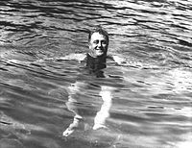

Boll Weevil
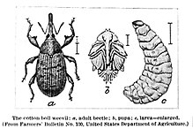
The boll weevil is an insect whose larva feeds on the cotton plant. By 1915 it had migrated to Georgia and drastically reduced the state’s cotton crop.

The boll weevil had a huge impact on Georgia’s economy and rural (farming) population. Due to the loss of cotton farms millions of African-Americans moved to northern cities. In addition, many sharecroppers and tenant farmers, both Black and white left the farms and moved to Georgia cities such as Atlanta and Macon or migrated into northern cities in search of employment. Cotton stopped being Georgia’s primary agricultural product.

In addition to the damage caused by the boll weevil, Georgia farmers suffered through another natural disaster in the 1920’s and 1930’s: drought. These droughts severely impacted Georgian’s ability to farm. With the damage caused by the boll weevil and the droughts, Georgia began to suffer from a depression long before the rest of the United States. The economic boom experienced by the rest of the United States ended with the Stock Market Crash of 1929. In this downturn, stock-holders lost over 40 billion dollars, and businesses were never able to recover from these losses throughout the 1930’s.

Franklin D Roosevelt
New Yorker Franklin D. Roosevelt’s devotion to Georgia when he contracted poliomyelitis (polio). In 1924, Roosevelt learned of the curing waters at Warm Springs, Georgia. Seeking treatment for his polio condition, Roosevelt began a years-long relationship with the small community of Warm Springs and with the state of Georgia. In 1932, the presidential election, Georgians enthusiastically supported Roosevelt. As a result of his time spent in rural Georgia, he witnessed first-hand the poverty that enveloped the state during the late 1920s and early 1930s. As president, he created several New Deal programs, including the Agricultural Adjustment Administration and the Rural Electrification Administration, which was clearly influenced by his time in rural Georgia.

During his fourth term, Roosevelt died at his Warm Springs home from a stroke. Roosevelt’s inspiration to fellow “polios” allowed the Georgia Warm Springs Foundation to be established in 1927. This facility, known today as the Roosevelt Warm Springs Rehabilitation Center, continues to provide care for those suffering from lingering effects of polio, stroke victims, spinal cord injuries and a great variety of disabilities. Roosevelt’s home at Warm Springs, the Little White House, is the only home that Roosevelt ever built for himself.
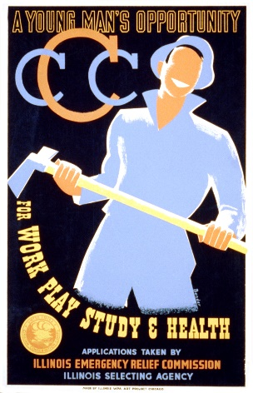
New Deal Programs
The Civilian Conservation Corps (CCC) 1933-1942
The purpose of the program was to hire unemployed young men to work on public service projects like erosion control, flood prevention, and public parks. Men who volunteered for this service signed six month contracts and were provided room and board. In addition, they also received $30 a month, $25 of which had to be sent back to their families. Of all of the New Deal programs, this was probably the most successful and popular. Over the nine years it was in existence, over 3 million young men worked in the program and planted millions of trees throughout the country.
However, once the U.S. entered World War II, these men changed out of their CCC uniforms and into military ones. In 1942, the CCC was disbanded

Rural Electrification Administration (REA) 1936
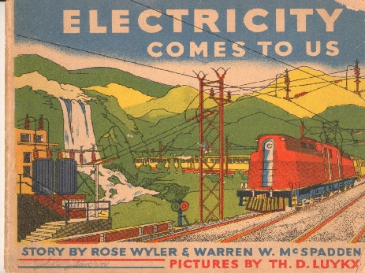
Roosevelt had an interest in bringing electricity to all parts of the country. In 1935 the Rural Electrification Administration was established to do just that. Though many members of Congress and state governors, such as Georgia’s Eugene Talmadge, fought against this program, fearing it would lead to Communism, many farmers benefited from it. According to the New Deal Network, by 1939 there was a 25% increase in the number of rural households that had electricity, and for a reasonable price. If they could afford it, many farmers bought appliances that used electricity which helped stimulate the economy. Since Georgia was a rural state during this time period, many Georgians also benefited from the program.

The Agricultural Adjustment Act (AAA) 1933
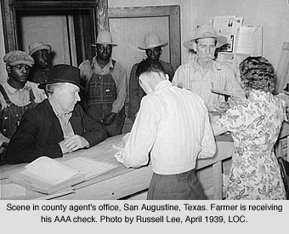
One of the New Deal programs to have a lasting effect on Georgia was the Agricultural Adjustment Act (AAA). The basic premise of the AAA was that, since so many farmers continued to grow crops such as cotton and tobacco during the Depression which drove the prices of these products down, the federal government offered to pay farmers not to grow those crops. This caused the price of agriculture products to rise which helped famers make more money and eliminate extra production. Yet, in many cases, this policy did more harm than good for sharecroppers and tenant farmers. Though the government told the landowner that the payments should be distributed to those who lived on and worked the land, many landowners simply kept the money for themselves. The government could not enforce this rule and, as a result, many of the people who needed this aid never received it. Often, since the sharecropper or tenant farmer could not work the land, they were simply removed. This was one of the factors that led to urbanization and the end of sharecropping and tenant farming in the state.

Social Security Administration (SSA) 1935
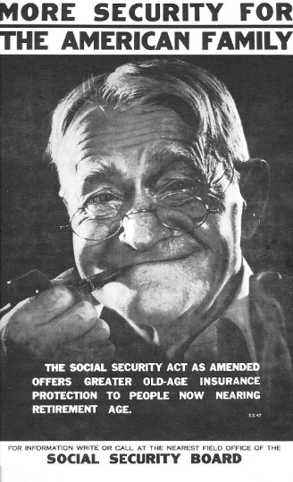
Until 1935, those who were too old or unable to work were dependent on the charity of others. The Social Security Administration offers benefits for those over 65, those who are disabled, or those who are the survivors of a beneficiary who has died. This program is one of the longest running of the New Deal, and today most Georgians are connected to the SSA either through paying social security taxes or receiving social security benefits.

Eugene Talmadge

After presenting himself as an advocate for the farmer and common man, Eugene Talmadge was elected Governor of Georgia in1932 and 1934. Talmadge also made decisions that hurt the state. He fought against Roosevelt’s New Deal policies, especially those that aided African-Americans. As Georgia’s governor, Talmadge’s lack of cooperation in the New Deal programs showed his negative opinion of Federal government help. He did not support federal relief programs, especially those that paid African American employees as much as whites. His continued attacks on Roosevelt’s programs polarized Georgia in the 1936 Democratic primary. Talmadge would see defeat in future elections, indicating that Georgia was becoming more conservative and moving away from New Deal programs.

In the 1946 election, rural Georgians helped to reelect Talmadge, who was running on a segregationist platform, for a fourth term. However, Talmadge died before taking office.

