I can describe Georgia’s contributions to World War I.
SS8H8 Analyze Georgia’s participation in important events that occurred from World War I through the Great Depression.
- Describe Georgia’s contributions to World War I.

Background
World War I was a major conflict fought between 1914 and 1918. Other names for World War I include the First War, WWI, the War to End All Wars, and the Great War.

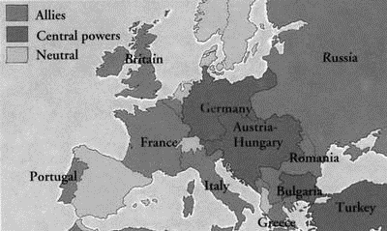
Who fought in World War I?
World War I was fought between the Allied Powers and the Central Powers. The main members of the Allied Powers were France, Russia, and Britain. The United States also fought on the sides of the Allies after 1917. The main members of the Central Powers were Germany, Austria-Hungary, the Ottoman Empire, and Bulgaria.

Where was most of the fighting?
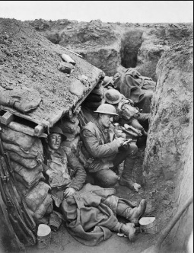
Most of the fighting took place in Europe along two fronts: the western front and the eastern front. The western front was a long line of trenches that ran from the coast of Belgium to Switzerland. A lot of the fighting along this front took place in France and Belgium. The eastern front was between Germany, Austria-Hungary, and Bulgaria on one side and Russia and Romania on the other.

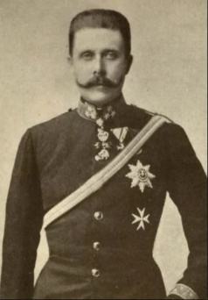
How did it start?
Although there were lots of causes for the war, the assassination (murder) of Austrian Archduke Franz Ferdinand was the main reason the war started. After the assassination, Austria declared war on Serbia. Then Russia prepared to defend its ally Serbia. Next, Germany declared war on Russia to protect Austria. This caused France to declare war on Germany to protect its ally, Russia. Germany invaded Belgium to get to France, which caused Britain to declare war on Germany. This all happened in just a few days.

America Becomes Involved
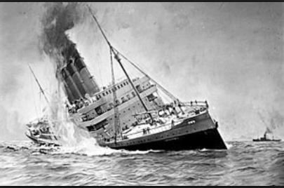
The Lusitania was a British passenger ship that was sunk by the Germans in 1915. Over 100 Americans were killed. The sinking of the Lusitania contributed to American entering World War I.

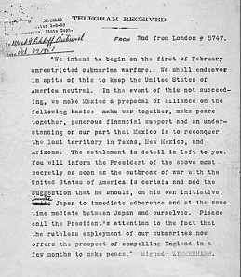
The Zimmerman Telegram was a telegraph sent from Germany to Mexico offering Mexico the opportunity for an alliance. Germany urged Mexico to attack the United States in return for territory lost during the Mexican-American War.

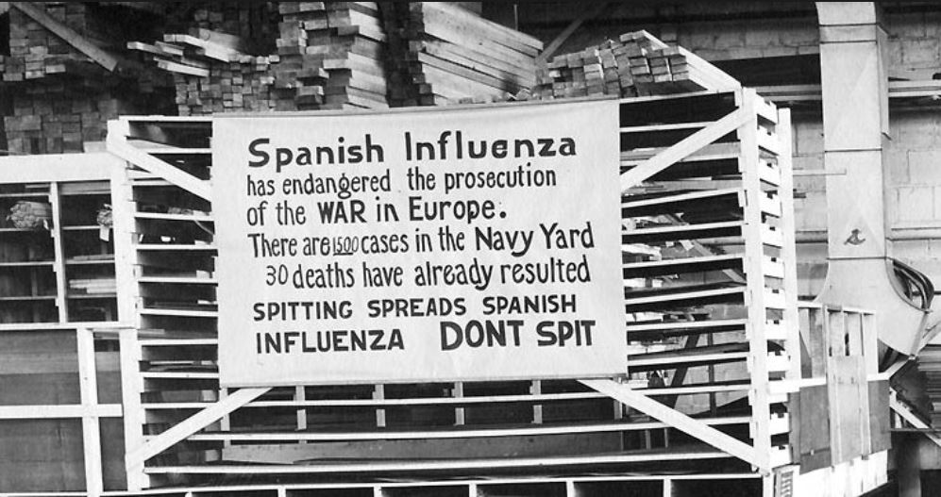
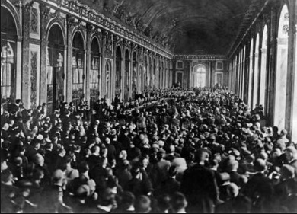
Major Battles
A lot of the war was fought using trench warfare along the western front. The armies hardly moved at all. They just bombed and shot at each other from across the trenches. Some of the major battles during the war included the First Battle of the Marne, Battle of the Somme, Battle of Tannenberg, Battle of Gallipoli, and the Battle of Verdun.
How did it end?
The fighting ended on November 11, 1918 when a general armistice (truce) was agreed to by both sides. The war officially ended between Germany and the Allies with the signing of the Treaty of Versailles.

Georgia’s Contributions to World War I
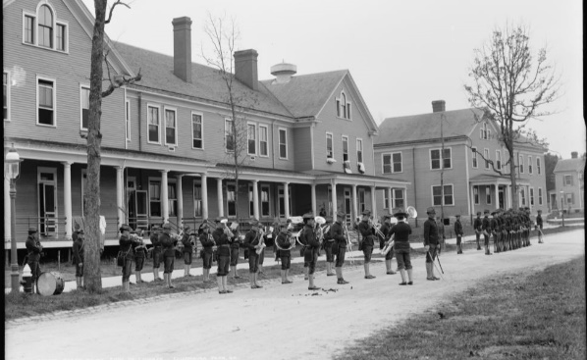
Georgia made several contributions to the U.S. war effort during World War I. Georgia supported five major federal military installations (forts) as the United States entered the war in 1917.

These forts provided the US military with necessary training and supplies. Georgia provided more military training camps for the war effort than any other state. In addition, over 100,000 Georgians took part in the war effort.

Over 3,000 soldiers from Georgia died fighting in World War I. Many Georgians also bought war bonds and grew “victory gardens” to help supply the troops.
During this difficult time period, there was an epidemic (widespread occurrence of disease) of Spanish Influenza (flu). Georgia training camps were impacted. The camps quarantined the sick people (kept them away from the healthy people) in an effort to keep the flu from spreading to surrounding communities. Unlike other east coast states, Georgia escaped the huge numbers of people who died from the flu.

Write Connections or Extra Notes Here

