I explain how Reconstruction impacted Georgia.
Lexile 990
- Identify the ways individuals, groups, and events attempted to shape the New South; include the Bourbon Triumvirate, Henry Grady, International Cotton Expositions, and Tom Watson and the Populists.

SS8H7 Evaluate key political, social, and economic changes that occurred in Georgia during the New South Era.

Bourbon Triumvirate
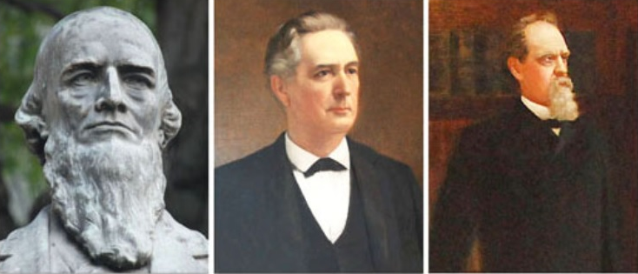
The Bourbon Triumvirate was a group of three politicians who were in charge of Georgia politics for over 20 years. These politicians’ names were Joseph E. Brown, Alfred H. Colquitt, and John B. Gordon. They were called the “Bourbon Triumvirate” because of their “Bourbon Politics” and because there were three of them.

All members of the Bourbon Triumvirate had been important people during the Civil War. Separately, each man also served as governor of Georgia and U.S. Senator from Georgia from the 1870s to the 1890s. These men all wanted to develop the railroad and mining industries in Georgia. They also wanted to do things to help the men who had been part of the antebellum (pre-Civil War) planter class (the rich 1%) before the Civil War. Finally, they wanted to lower taxes. This would result in fewer government services for poorer people.

Each member of the Bourbon Triumvirate was a white supremacist. Each member supported and took advantage of the convict lease system. This was the system of leasing (“renting”) convicted criminals/prisoners to business owners. The business owners would then provide housing, food, and clothing for the convicts, but the convicts had to work for free.

Through the efforts of The Bourbon Triumvirate, Atlanta became prosperous (wealthy). Eventually, the Bourbon Triumvirate lost power because the Populist Party and New Democrats, who were more liberal, began to dominate the Democratic Party in 1890. Also, the three members either died or retired.

Henry Grady
Henry Grady is famous for promoting what he called the “New South.” He was the editor of the Atlanta Journal, Atlanta’s most popular newspaper. Henry Grady used the newspaper to promote his views. Specifically, he wanted the south to have more industry (producing goods) and to plant different kinds of crops, not just cotton. Henry Grady also asked northern investors to give money to help both causes. Henry Grady was important because he helped bring the International Cotton Expositions to Atlanta. He also helped create the Georgia Institute of Technology (Georgia Tech). Henry Grady was active in local politics.
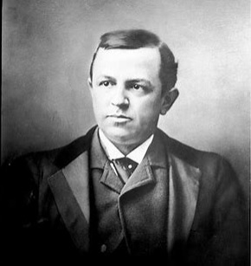
Henry Grady was an excellent writer and speaker. He is one of the most important figures in the New South movement. Henry Grady was only 39 when he died, but he had several important accomplishments in his short life. Because of his achievements, Henry Grady has been honored in several ways throughout Georgia. He has a county named after him. Grady Hospital is named after him, and the University of Georgia’s Grady School of Journalism is named after him as well.

International Cotton Expositions
Atlanta held three International Cotton Expositions in 1881, 1885, and 1895. The main purpose of the Cotton Expositions was to promote Atlanta’s rebuilding from the Civil War, its industrial capabilities and accomplishments, and to lure northern investment into the city and region.
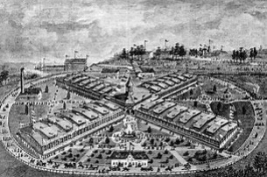
The most memorable Exposition was held in 1895. During this exposition, civil rights activist and educator Booker T. Washington gave his famous Atlanta Compromise Speech. This speech urged African-Americans to focus on economic improvement as opposed to political and social rights. This idea was supported by white New South advocates but was not accepted by African-American leaders such as W.E.B. Dubois. The Exposition was heavily promoted, but only 800,000 people attended the three-month event. This event suffered financially. However, all three Cotton Expositions were effective in displaying Atlanta’s “rise from the ashes” and to establish it as the leading city of the New South.

Tom Watson and the Populists
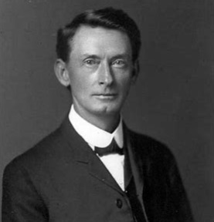
Tom Watson and Georgia’s farmers didn’t agree with Henry Grady’s focus on industrialization. They criticized Henry Grady for being more focused on Atlanta than on the needs of the rest of Georgia. Also, many civil rights groups didn’t agree with how inaccurately Henry Grady spoke about race relations in Georgia. They thought he was just trying to get northerners to invest in Georgia.
Tom Watson was a Congressman who supported the end to the convict lease system and was an advocate (supporter) of public education for all Georgians. Watson helped create the Populist Party which focused on lower taxes for poor farmers. Watson received the support of many rural black voters due to his condemnation (disapproval) of lynching. Unfortunately, around 1904, Watson began to change his open-minded views toward race and, by the end of his life he was a passionate white supremacist. He not only targeted African-Americans but Catholics and Jews as well.

