I can explain how Reconstruction impacted Georgia.
Lexile 890
c. Compare and contrast the goals and outcomes of the Freedmen’s Bureau and the Ku Klux Klan.
d. Explain the reasons for and effects of the removal of African American or Black legislators from the Georgia
General Assembly during Reconstruction.

SS8H6 Analyze the impact of Reconstruction in Georgia.

Freedmen’s Bureau
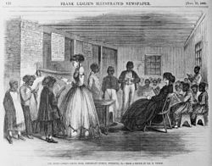
Two organizations were created during Reconstruction. Both affected the freedmen. The Freedmen’s Bureau was created to help African-Americans adjust to their newly-gained freedom. This program also supported poor whites in the South. The Freedmen’s Bureau provided food to whites and blacks who were affected by the war, helped build freedmen’s schools and hospitals, and supervised labor contracts and legal disputes. It also helped teach freedmen and poor whites to read and write.

Ku Klux Klan
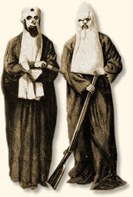
The Ku Klux Klan started in 1867 in Tennessee. At first, it was a social club for former Confederate soldiers. However, the KKK quickly became more political and violent. Soon after the group began, they began to use terrorism to bully freed blacks and white Republicans (people who wanted to help freed blacks). They would burn and bomb schools and churches. The KKK tried to keep freed blacks and Republicans from voting and running for office during Reconstruction. The KKK used violence and murder to torment and intimidate Black organizations so they could control African Americans and their white allies.

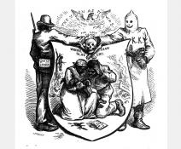
The KKK was successful in their political goals. The Democrats gained control of Georgia politics in 1871. Many of the Democrats were KKK members. Socially, the KKK often used severe acts of violence against the freedmen. In some cases, African Americans or Blacks rebuilt burned schools and churches, and sometimes even fought back when attacked. The KKK was a major force in Georgia during the Reconstruction Period. The white supremacy and racial segregation they championed became the norm in Georgia—and the rest of the South—for several decades.

The first KKK disbanded (separated) around 1871, when Democrats started to regain political control of the state (there wasn’t a need for an anti-black group anymore since they controlled the governmet) and the United States Congress (President Ulysses Grant) passed laws against the KKK. A new version of the KKK resurfaced in 1915.

Removal of African American or Black Legislators

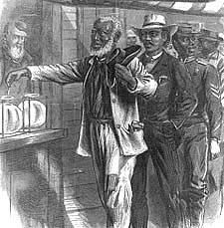
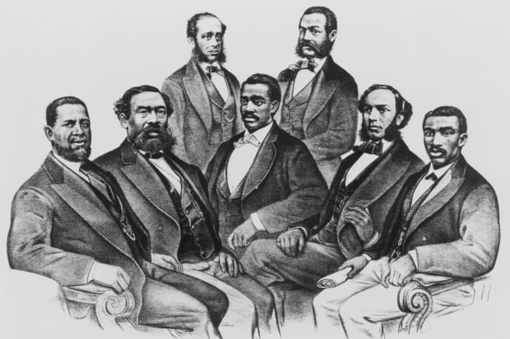
For a brief period during Reconstruction, African American or Black freedmen were give more political rights than they had ever had, and would not have again for 100 years. Most important, the freedmen were given the right to vote (15th amendment). With this freedom, 32 African Americans were elected to the Georgia General Assembly (Legislative branch in Georgia) in 1867. However, just a few days after the session began, these African American or Black legislators were expelled from the legislature.

There were many reasons these legislators were expelled. As recorded in the Journal of the Senate in 1868, the African Americans or Blacks were simply “persons of color” and, as “non-citizens,” were not allowed to hold office under Georgia’s Constitution.

Georgia’s Democratic legislators looked all through the state Constitution to find anything that supported the expulsion. The Democrats tried to say that many of the African American or Black legislators were unfit to serve because they had prior arrest records, were illiterate, or were unethical. Most of these accusations were untrue, but the legislators were forced out anyway.

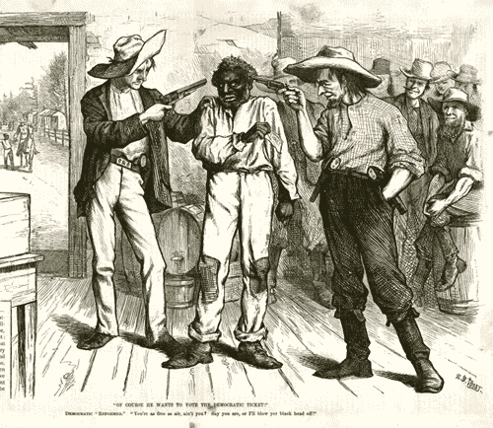
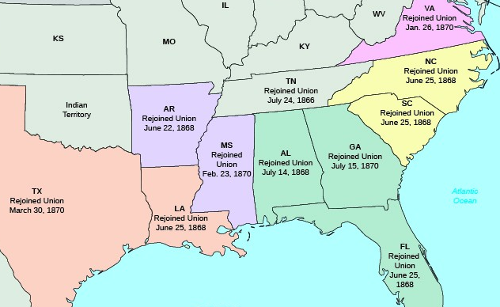
Other African-American or Black political leaders also suffered. They were kicked out of their homes, beaten, falsely accused of crimes, and harassed or even murdered by the KKK. Georgia’s poor treatment of its African American or Black legislators earned the state a negative reputation.

African Americans or Blacks Fight Back

Many African Americans decided to march in a political rally where they were ambushed by locals, who killed twelve marchers and wounded over thirty others. The violence scared many African Americans from voting in the 1868 Presidential election. Even if they did vote, their votes were often destroyed or changed to Democratic votes, since Georgia didn’t use a secret ballot. Republican members of the United States Congress were shocked at the violence and fraud in Georgia and they required Georgia to be put under military rule.

Military Control and Readmission to the Union

Georgia still wasn’t able to become a state and was controlled by the US military. The military removed the Georgia General Assembly’s Democrats and replaced them with the African American legislators who were removed in 1868.
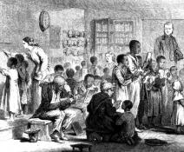
One of the most important contributions of the black legislators of the Reconstruction period was their support of public education. Due to their efforts, the 1868 Constitution called for free general public education in the State of Georgia. Free general public education began in 1872.

By early 1870, Georgia’s General Assembly ratified the Fifteenth Amendment and chose new Senators to send to Washington. In July of 1870, Georgia was readmitted to the Union.

