I explain how Reconstruction impacted Georgia.
Lexile 890
- Explain the roles of the 13th, 14th, and 15th Amendments in Reconstruction.
- Explain the key features of the Lincoln, the Johnson, and the Congressional Reconstruction plans.
- Give examples of goods and services produced during the Reconstruction Era, including the use of sharecropping and tenant farming.
SS8H6 Analyze the impact of Reconstruction in Georgia.

Background
Reconstruction was a time of major change in Georgia. Reconstruction lasted from 1865-1872. There were three Reconstruction plans. This was right after the Civil War. Even though this was a short time period, the effects lasted a long time.

After the Civil War, much of Georgia was destroyed because of Sherman’s March to the Sea and all the other fighting. Over 40,000 Georgia citizens had been killed or wounded. Many citizens had lost all their land. During Reconstruction, the United States attempted to reconstruct (rebuild) the south.

For a while, both African-Americans and Republicans gained power in Georgia. African-Americans were freed from slavery and gained more freedoms and educational opportunities. Organizations such as the Freedman’s Bureau helped them. They didn’t have these freedoms for very long.

Not everybody thought African Americans deserved these freedoms. African-Americans faced new challenges in both cities and rural (country) areas. In fact, soon after Reconstruction ended, southern Democrats regained political power. White supremacy and Jim Crow laws were in place for over 90 years.

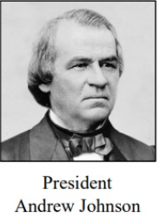
Reconstruction Plans and Amendments
Three Reconstruction plans were enacted in Georgia from 1865-1872. Three Constitutional amendments were intertwined with these plans, so we have to study them together.

The first Reconstruction plan was called Presidential Reconstruction. Abraham Lincoln was assassinated in April of 1865. The new president, President Andrew Johnson, didn’t want to punish the Southern states. He said the South could come back to the Union if 10% of the population swore an oath of allegiance to the United States. States were also required to ratify (pass into law) the 13th amendment, which officially ended slavery in the United States.

Georgia held a constitutional convention and was allowed back into the Union. However, there were problems because Georgia sent former high-ranking CSA officials to Congress. This made the Radical Republicans angry because they didn’t think CSA officials should serve in Congress. The Radical Republicans were also very upset by how the South was treating the freedmen (freed slaves). The South passed laws called Black Codes. Black Codes were laws created by Southern legislatures during Reconstruction that took away the civil rights of freedmen.

Under the Black Codes, blacks were not allowed to vote, testify against whites in court, or serve on a jury. To combat the Black Codes, the United States decided to introduce the 14th amendment. The 14th amendment made African-Americans citizens of the United States. It also required that states give African-Americans the same rights as all U.S. citizens. Georgia refused to ratify the 14th amendment.
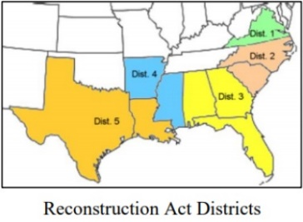
The next Reconstruction plan was called Congressional Reconstruction. During Congressional Reconstruction, Congress took responsibility for bringing the South back into the Union. Georgia and other Southern states still refused to pass the 14th amendment. This meant they weren’t allowed to be part of the Union. So, Congress passed the Reconstruction Act of 1867. This put Georgia under the authority of Congress. Congress also required Georgia and other Southern states to pass the 14th amendment before they were allowed back into the Union. Additionally, the Union sent the military to Georgia.

Congress soon introduced the 15th amendment, African American suffrage (right to vote). Georgia passed this amendment and was readmitted into the Union in 1870.

Goods and Services
Georgia was in big trouble at the end of the Civil War. General Sherman’s scorched earth policy meant that warehouses, factories, and railroads were burned as well as tools and farming equipment. The slaves were freed, so the South didn’t have anyone to work their fields. Also, the South’s banking system had failed. Things didn’t look good.

At the end of the war, Georgia’s farmers really wanted to sell the cotton they had in storage. Farmers and plantation owners thought they would need lots of workers to produce cotton in the future. Farmers divided their large plantations into smaller farms. Even so, the farmers weren’t planting as much as they were before the war. Georgia continued to produce more cotton than anything else. This was a problem because cotton had several bad seasons in a row, and the farmers lost money. As a result, Georgia struggled for many years.

Restrictions on trade between the North and South were slowly removed. Northern factories began sending their goods south. Southern businesses which sold these goods made a lot of money. Georgians were able to buy things on credit. Retail stores in major Georgia cities such as Atlanta, Savannah, Atlanta, Columbus, Augusta, and Macon supplied items to citizens.
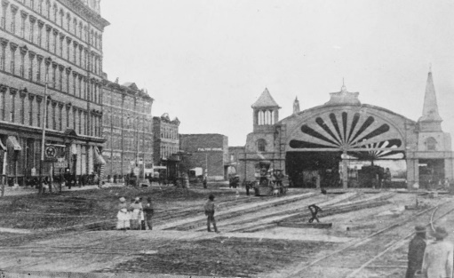
Atlanta grew quickly because citizens worked very hard to rebuild the railroads. 20,000 people moved to Atlanta by 1867, and the city began to grow. Atlanta was made Georgia’s capital in large part because it was so important to Georgia’s economy.

Other cities contributed too. Columbus was important for manufacturing. Savannah shipped cotton. There were textile mills all over Georgia and those were important to Georgia’s economy.

Although some of Georgia’s citizens were benefiting economically, many more were struggling to make ends meet. Agriculturally-based businesses were hit especially hard.

Sharecropping and Tenant Farming
After the Civil War, people in the former Confederate states had problems with “hard currency.” The Confederacy had printed its own money, but it was now worthless. Many of the major land owners couldn’t pay the people who worked for them. Workers had a hard time finding jobs that pay well. Land owners began the practices of sharecropping and tenant farming.
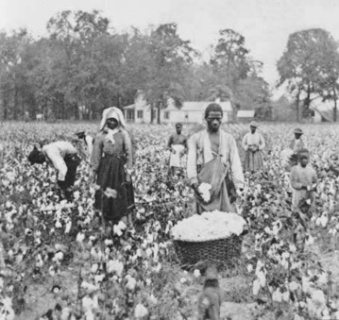
Sharecroppers were farmers who agreed to work on a landowner’s property in exchange for land, farming equipment, and seed. Sharecroppers were required to provide the land owner with a share of the crop.

Tenant farmers were farmers who agreed to work on a landowner’s property. They were required to provide the landowner with a share of the crops or an agreed upon amount of cash.

Sharecroppers and tenant farmers were usually poor blacks and whites who could not read or write. They had to agree to work for the land owner and give him part of their crops in exchange for land to work. They also had to buy things they needed do their jobs from the land owner’s store.

Both sharecropping and tenant farming kept the workers owing money to the people who owned the land. It was nearly impossible for sharecroppers and tenant farmers to get out of debt. The major differences between sharecroppers and tenant farmers is that tenant farmers usually owned their own tools, animals, and other equipment. Sharecroppers usually didn’t own anything. They just provided labor. Sharecropping and tenant farming were common in Georgia until the mid-20th century.

