I can discuss how Georgia was involved in the Civil War.
b. Explain Georgia’s role in the Civil War; include the Union blockade of Georgia’s coast, the Emancipation Proclamation, Chickamauga, Sherman’s Atlanta Campaign, Sherman’s March to the Sea, and Andersonville
Lexile 900-1000
SS8H5 Analyze the impact of the Civil War on Georgia.

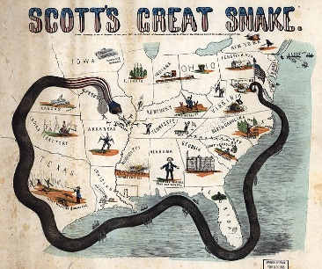
Union Blockade
The Union Blockade (something that prevents access to and from a place) of Georgia’s coast was one of the North’s most important strategies (way of reaching goals) during the Civil War. The North had a better Navy than the South. The South had cotton it hoped to send to France and Great Britain in exchange for weapons. So, the North’s first goal was to use its navy to stop Southern ships from going to Europe. To do this, General Winfield Scott invented the “Anaconda Plan” to blockade the South. His plan was to “squeeze” the CSA (Confederate States of America/the South) to death.

Emancipation Proclamation
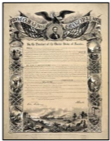
Abraham Lincoln wanted to promote his anti-slavery agenda. To do this, he needed the Union (North) to be stronger than the Confederacy (South). If the North was stronger than the South, Lincoln thought the country would take him more seriously. Lincoln encouraged his army to fight very hard. The Battle of Antietam (1862) was the bloodiest one-day battle of the Civil War. The battle was believed to be a tie with no clear winner. However, this battle was the “victory” Abraham Lincoln needed to release his Emancipation Proclamation. One week after the Battle of Antietam, Lincoln issued the Emancipation Proclamation on September 22, 1862. Most people think the Emancipation Proclamation is the document that “freed the slaves.” However, the Proclamation actually said all slaves in the rebellious states (Confederacy) would be freed on January 1, 1863. So, if the South had given up before January 1, they would have been allowed to keep their slaves. Also, Lincoln knew the CSA would not give up. He knew the Emancipation Proclamation would end slavery once the war was over. Finally, Lincoln knew slavery would become a question of right and wrong for Europe and that they wouldn’t want to become involved in the Civil War.

Chikcamauga
For the first three years of the Civil War, no fighting happened in Georgia. But the major effect of war came to Georgia in 1863, during the Battle of Chickamauga. The town of Chickamauga is located just 10 miles south of the Tennessee/Georgia line. The battle lasted three days. It lasted from September 18-20 and was the second bloodiest battle of the Civil War. There were over 34,000 casualties. The battle was the largest ever fought in the state of Georgia.

The Battle of Chickamauga was part of the North’s plan to take control of the city of Chattanooga. Chattanooga was important because it had a lot of sets of steel tracks for trains. The North planned to use Chattanooga’s capture as a stepping stone to capture Atlanta. Atlanta was important to the North because it had an even larger network of railroads.

Once the North defeated the South in the Battle of Chickamauga, General Ulysses Grant was promoted to Commanding General. Grant used the victories at Chattanooga and Chickamauga as a launching point for Sherman’s Atlanta Campaign.
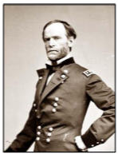
Sherman’s Atlanta Campaign
Sherman led two separate military campaigns in Georgia. The first was called the Atlanta Campaign. In the spring of 1864, Sherman set out to capture Atlanta. Capturing Atlanta would destroy the South because Atlanta was the major railroad hub of the South.

There was not one major battle to take Atlanta. There were several smaller battles that eventually allowed Sherman to move close enough to Atlanta to bombard it with cannon fire.

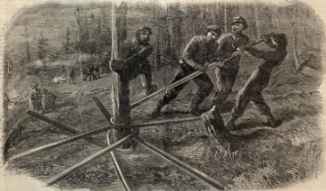
On September 2, 1864, the CSA was forced to withdraw from Atlanta, leaving the city open to Union control. Sherman was in control of Atlanta for more than two months. On Nov 15, 1864, Sherman’s army left Atlanta. As Sherman and his army were withdrawing, the city was set on fire. All but 400 buildings were destroyed. This meant that 90% of Atlanta was destroyed. The capture of Atlanta in September of 1864 was very important for two main reasons. First, the Confederacy lost most of its industry. Second, it gave the North a victory to celebrated and boosted their will to keep fighting. Additionally, Sherman’s Atlanta victory helped Lincoln become reelected in 1864.

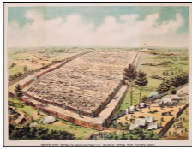
Sherman’s March to the Sea
After destroying Atlanta, Sherman set his sights on the rest of Georgia. He hoped to end the war as quickly as possible. He also wanted to punish the South for starting the war. So, Sherman began his war tactics of “Total War” on his infamous March to the Sea. The march began on November 15, 1864. It ended on December 21, 1864, when Sherman captured Savannah. The CSA lost a lot of soldiers and supplies during the battles of the Atlanta campaign and other fighting. So, the Union had a fairly easy time as they marched to the Atlantic Ocean.

During the march, Sherman’s “Scorched Earth Policy” created a path of destruction that was 300 miles long and 60 miles wide. He planned to destroy Georgia’s infrastructure—basic equipment needed for a business or society to operate—and anything that helped supply Confederate troops. This included railroads, roads, cotton gins and mills, warehouses, and bridges. Sherman believed that destroying the morale of Georgians would lead to a quick end of the war.

Many people in the south still think Sherman purposefully destroyed private homes. Historians believe Sherman ordered his troops to “loot the towns in the countryside.” They also believe he told troops not to trespass or enter private homes. Some of Sherman’s men didn’t listen and burned things they weren’t supposed to, looted civilian food supplies, and took civilian valuables as treasures of the march.

To many Georgians, General Sherman’s actions during the Civil War make him the most hated figure in the state’s history. No matter if Sherman was a truly a tyrant who rejoiced in his “mistreatment” of Georgia, or simply a military commander doing his job to quickly end the war, Sherman’s military campaigns through Georgia left an enormous impact on the social, economic and political history of the state.

Savannah was Sherman’s last stop. Its citizens knew what had happened to the rest of the state. They didn’t want to suffer the same fate. So, they surrendered to Sherman without a fight on December 22, 1864. Sherman wrote to Abraham Lincoln that Savannah was his Christmas present (along with about twenty-five thousand bales of cotton that was ultimately shipped to Northern factories).

Andersonville
Andersonville Prison is the most notorious prisoner of war (POW) camp from the Civil War era. It was built to hold only 10,000 Union prisoners of war. However, the camp’s population tripled to over 30,000 at the peak of its occupancy.
The main water source for the prison was a small creek that flowed through the camp. Once the prison began to reach its occupancy limits, this creek became infested with diseased human waste and other sewage.

Disease spread rapidly throughout the prison camp. In addition, due to the success of the Union blockade, the South was running low on food and other supplies for the prisoners. Finally, the Union prisoners turned on each other and a group of soldiers known as “the raiders” terrorized the fellow prisoners by robbing and beating them. Because of these horrible conditions, more men died (over 13,000) at Andersonville than at any other Civil War prison. At the end of the war, Captain Henry Wirz, the commander of the camp, was executed by the North for war crimes. He was the only CSA official to meet this fate. Some people supported Wirz’s execution due to the harsh treatment of the Andersonville prisoners and the high death rate. Others believed that Wirz did what he could to run the prison with the South’s lack of resources and the decision by his superiors to continue sending prisoners to the already overcrowded prison.

