I can teach others about the problems and events that led to the Civil War
Flesch-Kincaid Reading Level: 6
a. Explain the importance of key issues and events that led to the Civil War; include slavery, states’ rights, nullification, Compromise of 1850 and the Georgia Platform, the Dred Scott case, Abraham Lincoln’s election in 1860, and the debate over secession in Georgia
SS8H5 Analyze the impact of the Civil War
on Georgia

When Georgia was a Trustee colony, slavery was not allowed in Georgia until the early 1750’s. Once it was legalized, slavery grew quickly due to Georgia’s agriculture-based economy, then even faster when the cotton gin was invented. The South’s economic dependence on cotton led to a change of attitude about the evils of slavery. More and more people in the South believed it was necessary.
In turn, many in the North, led by abolitionists such as Frederick Douglass, William Lloyd Garrison, and Harriet Beecher Stowe, began to despise slavery and call for its end. Others simply became uncomfortable with its existence in America and disagreed with its expansion.
The gap between the two regions widened every time the U.S. gained more territory. The South hoped for slavery to expand into the new territories while many in the North wanted it, at the very least, to be contained to where it already existed. As with the other slave states, Georgia wanted slavery to expand and was distrustful of the abolitionist movement taking place in the North.
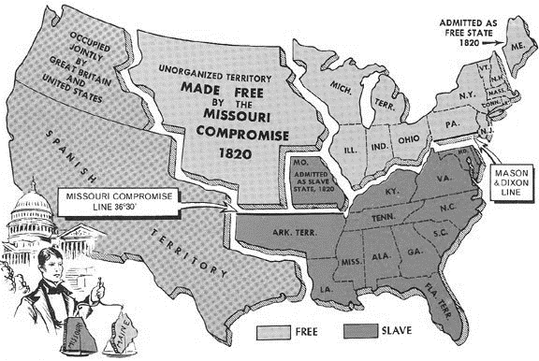
A major conflict in the history of the United States, from its creation to the present, is the issue of states’ rights. States’ rights regard the amount of power a state government has compared to the amount of power held by the federal government when making decisions. Early in the United States’ history, the Articles of Confederation gave the individual states too much power. All of the signers of the U.S. Constitution knew that the federal government needed to have more power than it had under the Articles of Confederation to run the country effectively. Even though the Constitution was signed, many states did not agree with the federal government taking away many of the state’s rights.
The states began to fight back. Many states disagreed with a tariff (tax on imports and/or exports) the government put into place. This disagreement caused the Nullification Crisis in the 1830s. The North supported high tariffs to subsidize their young manufacturing industry against the cheaper products that could be sent to the United States by other countries. The South was opposed to this tariff because it took away profits from cotton farmers. When the Northern states, who dominated the House of Representatives, voted to renew the tariff, South Carolina threatened to nullify (void/ignore) the tariff and even possibly secede (separate/break away). However, Andrew Jackson’s threat to attack South Carolina if they attempted to leave the union worked well enough to keep the country united for a while.
The issues of slavery, tied with the concept of states’ rights, left a huge crack in the country. Arguments kept happening for almost 40 years while Congress tried to close wounds with compromises and acts that acted as temporary Band-Aids. Though these acts and compromises kept the country together in the short term, as Abraham Lincoln said “A house divided against itself cannot stand.” Over time, a physical war between the North and South appeared to be unavoidable.
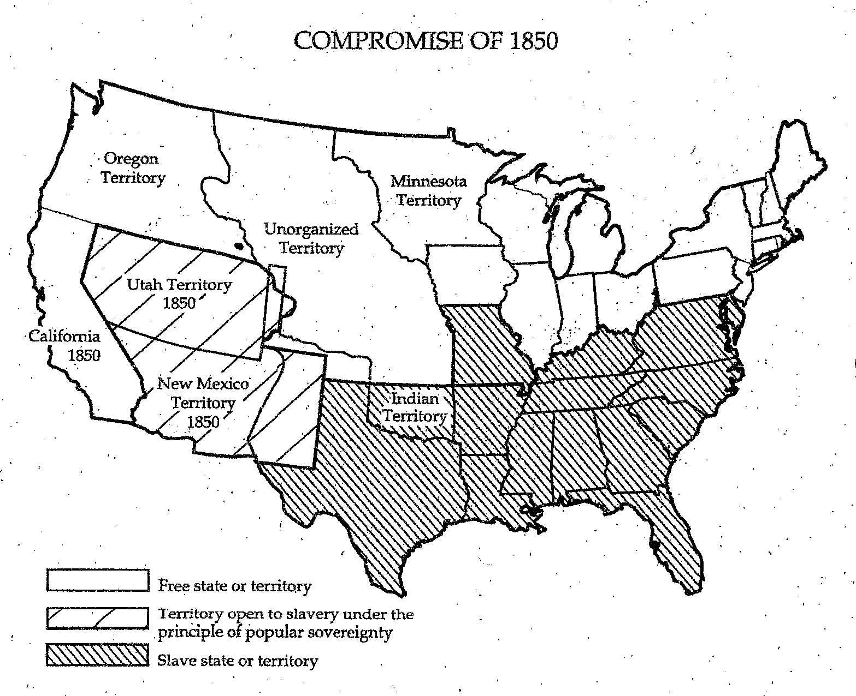
The first compromise was the Missouri Compromise, an agreement between the northern and southern states about allowing Missouri to become a state. The issue with this compromise focused on disrupting the balance of power between the slave and free states in Congress. Allowing Missouri to enter as a slave state and Maine to enter as a free state enabled the balance of power to remain the same. This pattern changed in 1850 when California applied for statehood. With no slave state available to balance the entry of a free one, major conflict ensued between the North and South. The South became nervous about the imbalance in Congress, therefore a new compromise had to be met.
The Compromise of 1850 contained two important rules to solve the issue of California. The first was California was admitted as a free state resulting in a power imbalance in both the House and Senate. In turn, Northern congressmen agreed to pass the Fugitive Slave Act, which guaranteed the return of any runaway slaves to their owners if they were caught in the North. There was much protest in the North to this act but the southern leaders believed it would protect the institution of slavery.
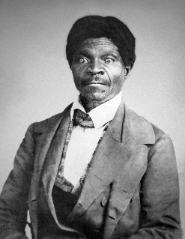
While debate over the Compromise of 1850 was raging in Congress, prominent Georgia politicians were deciding if the state should accept the terms of the Compromise. Led by Alexander Stephens, Georgia provided a response to the compromise, known as the Georgia Platform. This document outlined southern rights as well as the South’s commitment to the Union. It established Georgia’s uncertain acceptance of the Compromise of 1850. With Georgia leading the way, other southern states also accepted the Compromise preventing a civil war for 11 years.
The Dred Scott Case (1857) ended in a Supreme Court ruling that greatly favored the south and lead to more division between the North and South. Dred Scott was a slave who was taken by his master to the free states of Illinois and Wisconsin. Upon his return to Missouri, Scott sued the state based on the belief that his time spent in the free states made him a free man. When the case made it to the Supreme Court, the court ruled on the side of Missouri, forcing Dred Scott back into slavery. The Court went on to declare that slaves and freed blacks were not citizens of the United States and did not have the right to sue in the first place.
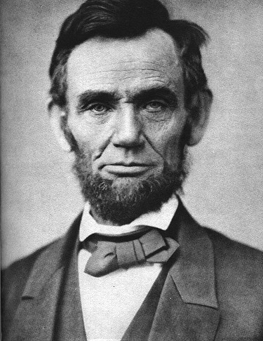
The final situation that plunged the United States into the Civil War was Abraham Lincoln’s election in 1860. Due to the dramatic divide in the country, four presidential candidates ran for office in 1860. These men were Abraham Lincoln, John Breckenridge, John Bell, and Stephen Douglas. Lincoln was the nominee of the Republican Party, a party that began in 1854 and whose primary goal was to prevent the expansion of slavery. Georgia would ultimately stand with candidate John Breckenridge who supported the expansion of slavery. Lincoln was not on the ballot in Georgia as he was not in most southern states
Lincoln won the election of 1860 with 180 electoral votes (152 electoral votes were needed to win at that time). After the election, the southern states, believing that Lincoln’s ultimate goal was to end slavery, voted one by one to secede from the Union, South Carolina being the first. Georgia, after a three-day debate, voted to leave the Union on January 19, 1861.
In 1861, there was a spirited debate over secession in the Georgia General Assembly (legislative branch in Georgia) to determine if Georgia should join its southern neighbors in breaking away from the Union. Georgia eventually seceded from the Union after several other southern states. Georgia was part of the Confederacy from 1861-1865.
During the debate, there were those who did not want to leave the Union, including representatives from the northern counties, small farmers and non-slave holders, and most importantly Alexander Stephens (future vice-president of the Confederacy), who gave an eloquent speech against secession. On the other side, were large farmers, slave holders, and powerful and influential men.

