a. Explain the causes of the American Revolution as they impacted Georgia; include the French and Indian War, Proclamation of 1763, and the Stamp Act.
b. Interpret the three parts of the Declaration of Independence (preamble, grievances, and declaration) and identify the three Georgia signers of the document.
c. Analyze the significance of the Loyalists and Patriots as a part of Georgia’s role in the Revolutionary War; include the Battle of Kettle Creek and Siege of Savannah.
d. Analyze the weaknesses of the Articles of Confederation and explain how those weaknesses led to the writing of a new federal Constitution.
SS8H3 Analyze the role of Georgia in the American Revolutionary Era
Georgia’s revolutionary history includes men and women who challenged British authority at a potential cost to themselves, their families, and their businesses. Taking a side would place these men and women in difficult circumstances.
Causes
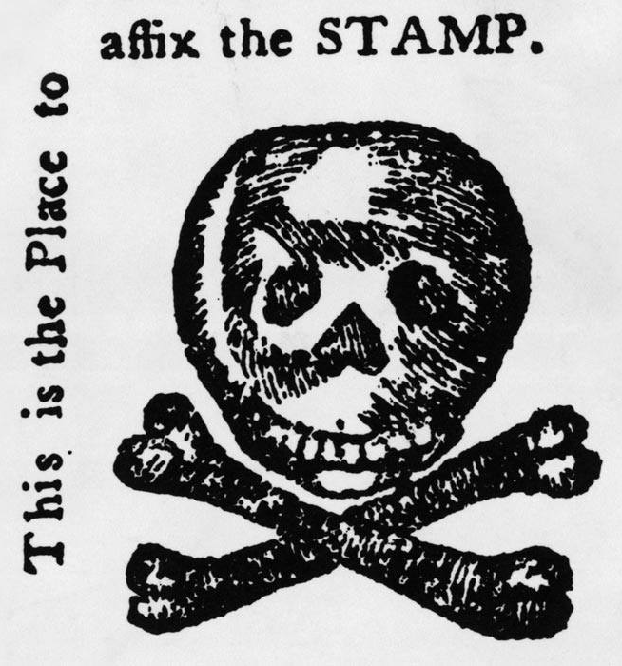
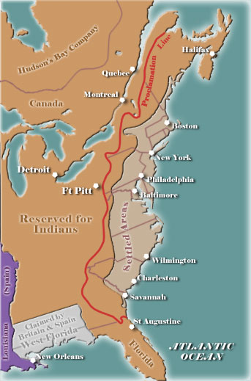
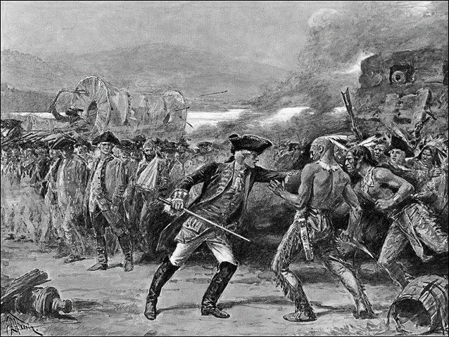
The causes of the Revolution did not have the same impact on Georgia as they did on other colonies. For example, the French and Indian War (1754-1763), a conflict between France and England for control of the rich fur region of the Ohio River valley, was fought far from Georgia’s borders and had a very small impact on the state. Due to the debt (money that is owed to someone else) created by this war, there were two important events that led to conflict between Britain and its colonies. The first was the Proclamation of 1763, and the second was a series of taxes, including the Stamp Act (1765), that led to angry colonists. The Proclamation of 1763 was issued by the King of England and banned colonists from settling lands west of the Appalachian Mountains. The Proclamation was issued in order to prevent further war between the Colonists and the Indians. Because of the debt of the French and Indian War, Britain could not afford more fighting. However, the colonists, many of whom participated in the war in hopes of gaining new western lands, were extremely upset by the Proclamation of 1763. In fact, many colonists simply ignored the Proclamation and settled in the river valley anyway. The people of Georgia did not share the same reactions to the Proclamation of 1763 for two reasons. First, the young Georgia colony was small and most colonists were still reliant on the King’s help. Secondly, Georgia gained land and resources after the French and Indian war. Due to the debt that the war caused, Britain believed that the colonists should be held responsible by paying new taxes. After the French and Indian War, colonists were being directly taxed for the first time without colonial “representation” (having colonists speaking for the colonies) in the British Parliament. This led to protests throughout the colonies. One of the earliest and most controversial taxes was the Stamp Act of 1765. This act put a direct tax on paper items that were commonly used by almost every colonist, including newspapers, licenses, and legal documents. Reaction to this tax in the colonies was often violent. Colonists protested by hanging effigies (sculpture or model of a person) of Parliamentary leaders and royal governors, attacking the homes of British officials, and tarring and feathering tax collectors. Some of these citizens, mainly from the middle and upper classes, joined a group called the “Sons of Liberty” in response to these taxes. Eventually, the British Parliament issued other acts to collect taxes. These acts caused even more discontent and set the stage for the Revolutionary War. Several prominent Georgians spoke out against the Stamp Act and in 1765 a group affiliated with the Sons of Liberty called the “Liberty Boys” was established to oppose it.
Declaration of Independence
The Declaration of Independence was the document officially declaring the colonies’ independence from Great Britain. It was adopted by the Continental Congress on July 4, 1776. The declaration was drafted by Thomas Jefferson. Three Georgians, Button Gwinnett, Lyman Hall, and George Walton signed the Declaration of Independence on behalf of the Georgia colony.
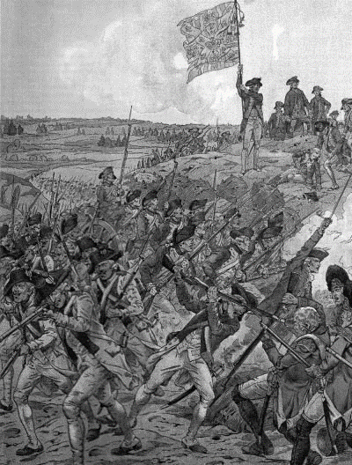
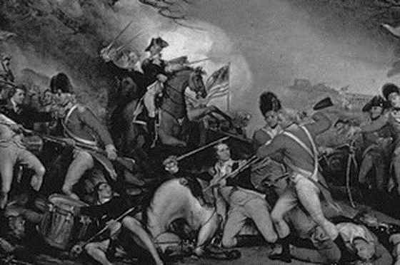
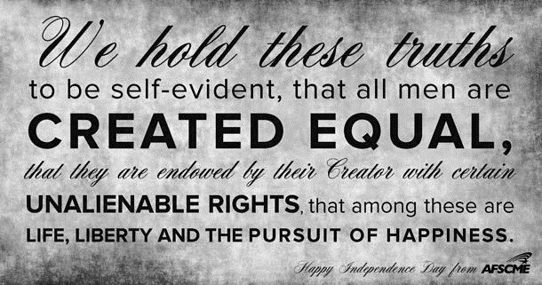
The Declaration of Independence is a document that is divided into three parts. The first part, the Preamble, explains to the reader about the natural rights of all people (though this has been debated), states the reasons for the document, and includes the famous quote “We hold these truths to be self-evident that all men are created equal, that they are endowed by their creator with certain unalienable Rights, that among these are life, liberty, and the pursuit of happiness.” The second part includes a list of grievances against King George III including “imposing taxes without our consent” and “quartering large bodies of troops among us.” The list details why the colonies deemed independence necessary. The final part is the actual “declaration of independence” and is where the colonists officially severed ties from Great Britain, the mother country. Anyone who signed the Declaration of Independence put their life on the line since creating the document was technically treason (betraying one’s country).
War breaks out
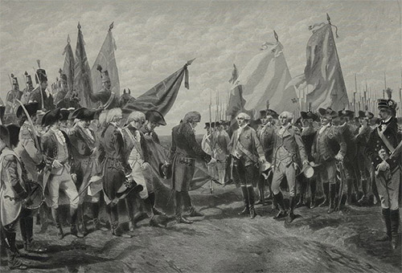
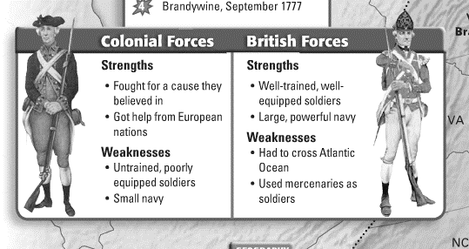
The Loyalists, as their name implies, were loyal to Britain and did not want the colonies to break away from the mother country (Britain). Because Georgia relied on the King’s money and protection, most of Georgia’s population were Loyalists. Loyalists were also called Tories. Patriots (colonists who wanted Independence and self-government) were outnumbered by the Loyalists in the Georgia colony.
War broke out between the Colonists and British soldiers when an accidental shot was fired at the Battle of Lexington and Concord in Massachusetts. This “Shot Heard Around the World” was the start of many battles throughout the colonies between Britain and the colonists. While the Patriots were trying to hold their ground in the other colonies, fighting in Georgia took an unexpected turn. A small group of Patriots defeated a larger group of 600 Loyalists in the Battle of Kettle Creek. Enjoying a boost in morale (confidence), the Patriots were able to take control of British-held Augusta. The Battle of Kettle Creek took place on February 14, 1779. In October 1779, a joint force of French and Patriot troops attacked Savannah in hopes of taking the city from the British. This attack was a miserable failure. After five days of intense fighting on both land and sea, little damage was done to the British military but several civilians in the city were killed. When the French and American troops finally attacked the city, they were easily defeated by the British troops. When the fighting ended, over 800 allied troops were killed compared to 18 British soldiers. Savannah stayed in British hands until 1782. It wasn’t until 1781 at the Battle of Yorktown in Virginia that the end of the American Revolution took place. With help from the French, the Patriots were able to corner their British enemies who were forced to surrender. Even though this is considered the end of the war, fighting didn’t officially stop until two years later.

