SS8H1 Evaluate the impact of European exploration and settlement on American Indians in Georgia.
a. Describe the characteristics of American Indians living in Georgia at the time of European contact; to include culture, food, weapons/tools, and shelter.
b. Explain reasons for European exploration and settlement of North America, with emphasis on the interests of the Spanish and British in the Southeastern area.
c. Evaluate the impact of Spanish contact on American Indians, including the explorations of Hernando DeSoto and the establishment of Spanish missions along the barrier islands.
People lived in Georgia long before its official “founding” on February 12, 1733. The land that became our state was occupied by several different groups for over 12,000 years.

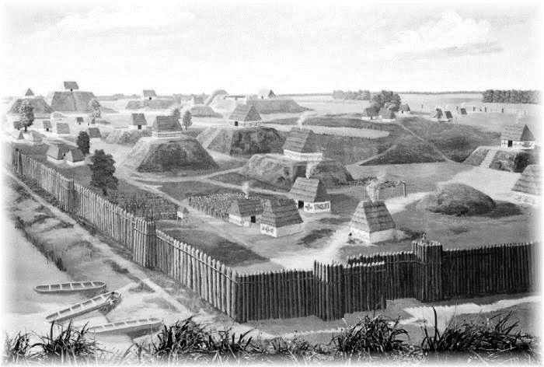
Indians in Georgia
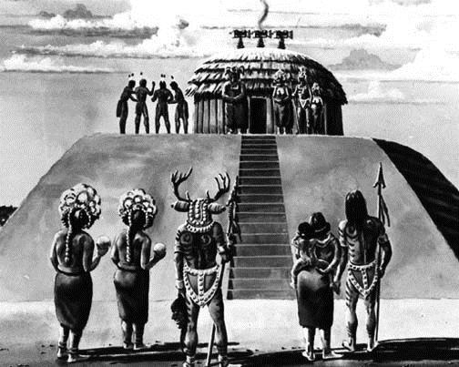
The Mississippian American Indians were living in Georgia when the Europeans, specifically the Spanish, arrived in the mid-1500’s. The Mississippians rose to dominance about 800 CE (Common Era) and organized themselves into a very complex “chiefdom” society. This organized hierarchical society was made up of a small number of “elites” (the power holders) and the majority were “commoners” (the work force). The Mississippians created large towns near rivers that featured a central plaza, housing zones and defense structures (palisades, guard towers and moats). The focus of the plaza was the earthen mounds, dedicated to religious and social activity though some served as cemeteries. Thousands of families lived in these towns. One-room wattle and daub shelters (walls built out of sticks and covered with mud or clay) served as places to sleep as they usually spent their days in the open. A widespread trade network connected Mississippian towns. Trade with other towns consisted of shell beads, pottery with abstract images, and stone tools. Early Mississippians practiced horticulture (garden cultivation) and eventually moved into large scale farming as their population grew. Initially, maize (corn) was their dominant crop and they eventually added squash, sunflowers, pumpkins, and beans. They still hunted and gathered. Using bows and arrows and knives, bone evidence indicates that they hunted deer, rabbit, muskrat, beaver, raccoon, and turkey. Turtle and fish were also a part of their diet. They gathered seasonal fruits, including plums, grapes, blackberries, and raspberries as well as a variety of nuts. The Mississippians improved on the stone tools of previous cultures to use in hunting, farming, and human conflict. After meeting the Spanish under Hernando DeSoto’s leadership in the mid-1500’s, many Mississippians died due to disease and the group eventually reorganized into the historic tribes of the Creek and the Cherokee.
European Exploration
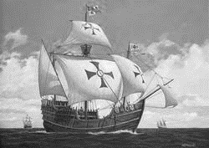
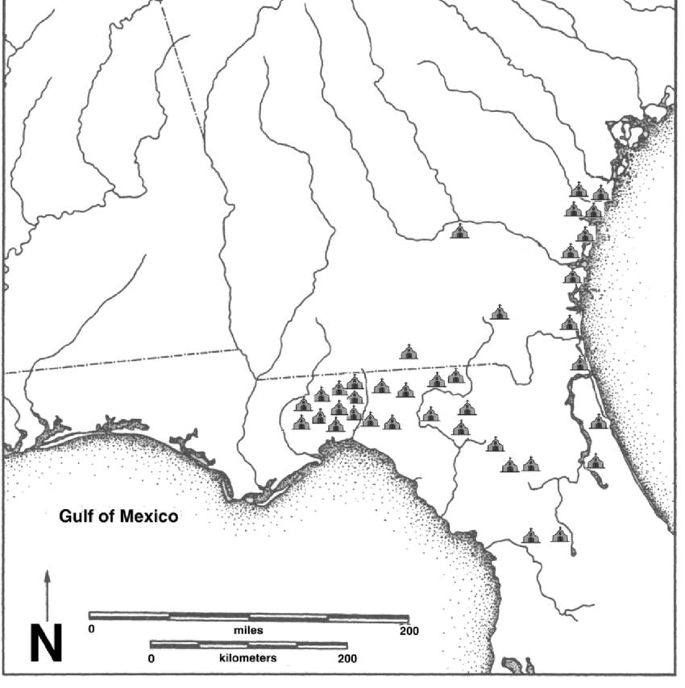
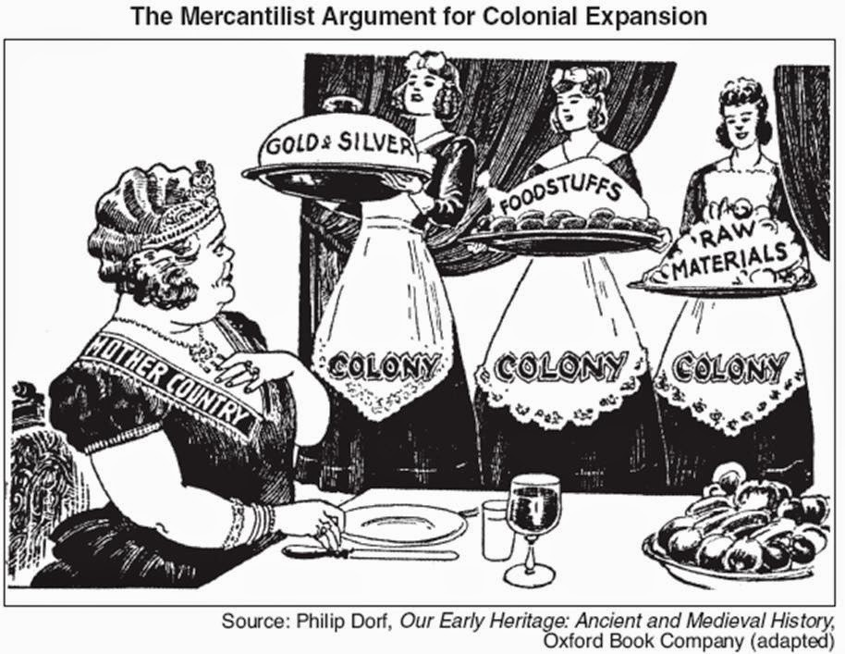
European nations had different reasons for exploring North America. Getting rich was a primary cause for the exploration of North America. Each desired to build a large empire that would create political and economic dominance in the world. France, interested in the fur trade in North America, was primarily interested in Louisiana, the Ohio Valley, and Canada. Spain was interested in North America (particularly the Southeast) for the three G’s: God, Gold and Glory. Converting the American Indians to Christianity, filling the Spanish King’s treasury with gold, and seeking personal fortune and fame were the goals of Spanish conquistadores (soldiers that take over an area by force). England desired to create permanent colonies in North America to support the economic policy of mercantilism (the economic policy in which a country seeks to export more than it imports) . The “mother country” created colonies that made raw materials that would be shipped “home” for production into finished products. These products would be shipped back to the colony for colonists to buy. Other reasons for creating colonies included a desire for “religious freedom” and a place to begin a “new life”

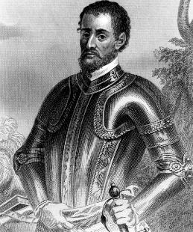
Spanish Exploration and Hernando De Soto
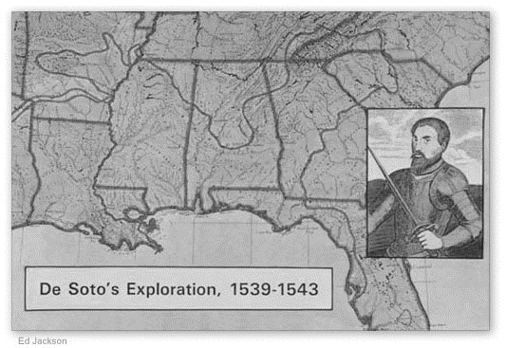
Spanish contact had a dramatic impact on the American Indian culture in Georgia. Hernando DeSoto, the first known European explorer in Georgia, was directly responsible for starving and killing a large number of American Indians in his quest for God, gold, and glory. Without a plan for exploration, DeSoto and his men moved from Florida into southwest Georgia in their search for gold. The American Indians often lied to DeSoto regarding massive areas of gold further north in an attempt to protect their own villages/towns. DeSoto’s journey is what introduced devastating diseases to the American Indian culture. DeSoto’s expedition failed. His men never found gold and he died near the Mississippi River and was buried in the river. Colonization efforts were mostly huge failures. However, the most successful Spanish colonization attempt was during the “Mission Period” from 1568 – 1684. It was during this period that Spain built several missions (churches) on the barrier islands as well as on the mainland. Spanish missions were located near Mississippian towns so the priests could achieve their primary goal: converting American Indians to Christianity (Catholicism). By the mid-1600’s, the Spanish mission system was crumbling. British influence from other colonies often encouraged American Indians to attack the missions and, by 1680’s, coastal missions were abandoned by the Spanish.

