I can describe the role of Georgia in modern Civil Rights
a. Explain Georgia’s response to Brown v. Board of Education including the 1956 flag and the Sibley Commission.
b. Describe the role of individuals (Martin Luther King, Jr. and John Lewis), groups (SNCC and SCLC) and events (Albany Movement and March on Washington) in the Civil Rights Movement.
c. Explain the resistance to the 1964 Civil Rights Act, emphasizing the role of Lester Maddox.

SS8H11 Evaluate the role of Georgia in the modern civil rights movement.

Summary
The 1940’s and 50’s saw a major push by African-Americans to fight segregation and reclaim the civil rights that were denied them during the Jim Crow era. The 1940’s and 50’s were a time of organized, and usually, peaceful resistance that helped to end these laws. African-Americans who were returning home from World War II began to push for civil rights. Nationally, organizations such as the NACCP went to court to fight against unjust segregation laws and won many of the cases. In turn, leaders such as Dr. Martin Luther King, Jr. and John Lewis of Georgia focused on ending segregation with the use of economic boycotts similar to the Montgomery Bus Boycott of 1954.

Georgia’s Response to Brown v. Board of Education
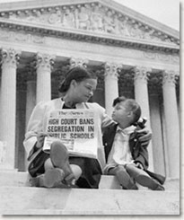
In 1954, Georgia’s response to the Supreme Court decision in Brown v. Board of Education (desegregate public schools) was deliberate and extreme. When segregationists heard the Court’s decision that racial segregation violated the 14th Amendment, these politicians determined that Georgia schools would not integrate (desegregate/all races together in one school). The Georgia General Assembly supported “massive resistance” and maintained a strong opposition to the forced integration of public schools.

Sibley Commission
A series of meetings were held to determine how Georgia would deal with desegregation called the Sibley Commission. After these meetings, 60% of Georgians claimed that they would rather close the public schools than to integrate. Despite the findings, Sibley pushed for schools in Georgia to desegregate on a limited basis. It didn’t look like Georgia was going to budge until the state tried to close the University of Georgia instead of integrating it. This caused a federal judge to step in and forbid the closing of the University. Seeing how bad closing schools in Georgia could be for the state Georgia’s governor gave in and asked the General Assembly to accept Sibley’s recommendations. Later that year, the city of Atlanta desegregated its schools.

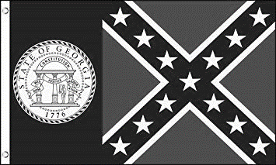
Georgia’s Flags
In 1956, to show their disapproval of Supreme Court decisions such as Brown v Board of Education, Georgia’s legislators voted to change the state flag to include the Confederate battle flag (the “stars and bars”). The state constitution provided the legislature the sole authority to change the flag. The public wasn’t allowed to vote on the change. While legislators denied that the change in flag design was a display of opposition to desegregation, the new flag design was almost certainly racially motivated. In 2001, Governor Roy Barnes attempted to pass a bill granting Georgia a new flag. Once the bill passed, the new flag design was revealed, supporters of the 1956 flag were livid, with some calling the new flag the “Barnes Rag”. Then Sonny Perdue came into office and changed the flag officially to the current state flag in 2004.

Dr. Martin Luther King, Jr.
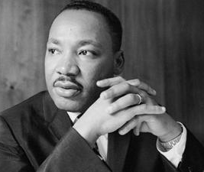
Leadership was essential to the success of the Civil Rights Movement. Georgians Martin Luther King, Jr. and John Lewis were at the forefront of the movement. Arguably, Dr. Martin Luther King, Jr. (1929-1968) is the most well-known Georgian for his tireless leadership in the Civil Rights Movement. His work and devotion to non-violent protest earned him the Nobel Peace Prize and led to the national holiday created in his honor. King was born in Atlanta and graduated from high school at the age of 15. He began his college studies at Morehouse College, a historically black institution of higher learning. King’s father and grandfather were both ministers, and King eventually chose the same profession. He earned his Ph.D. in Divinity from Boston University. It was there that he met his wife Coretta Scott.
In 1954, King accepted an offer to become the pastor a church in Montgomery, Alabama. While in Montgomery, he served as the spokesperson for the successful Montgomery Bus Boycott. Eventually, the Supreme Court made segregation on Montgomery busses unconstitutional. After the successful boycott, King created the Southern Christian Leadership Conference (SCLC). Shortly thereafter, he won the Nobel Peace Prize. King was instrumental in ending segregation and changing America’s views on race and racial equality. Unfortunately, while he did not live to see the results of his hard work, his efforts and leadership have led to an America where some of the ideals from his “I Have a Dream” speech have been met. Martin Luther King, Jr. is the only African-American or Black to have a federal holiday named in his honor.

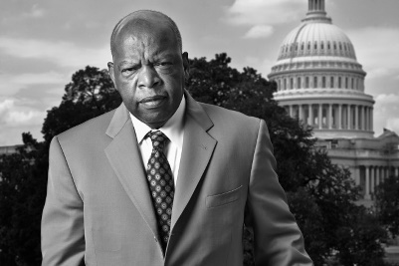
U.S. Representative John Lewis
U. S. Representative John Lewis (b. 1940) was born to sharecroppers in Pike County, Alabama. Lewis became a very important part of Georgia’s history through his leadership in the Civil Rights Movement. He was active in the 1960’s sit-ins to protest Jim Crow laws. He also participated in the Freedom Rides of the early 1960’s. Lewis became the chair of the new organization, the Student Nonviolent Coordinating Committee (SNCC - pronounced “snick”) devoted to civil rights change.
With Dr. King, Lewis was a keynote speaker at the 1963 March on Washington for Jobs and Freedom. In 1965, Lewis also led over 600 marchers across the Edmund Pettus Bridge in Selma, Alabama only to be beaten by Alabama state troopers. Television coverage of this “Bloody Sunday” event brought much needed attention to the Civil Rights Movement. In the late 1960’s and 70’s, Lewis continued his dedication to seeking civil rights through voter registration and volunteer programs.
Lewis was elected to the Atlanta City Council in 1981. He advocated for ethics in government and community preservation. In November 1986, Lewis was elected to the United States Congress, and he continues to serve today. Lewis has won numerous awards through the years that reflect his dedication to seeking civil rights for all. He has co-authored MARCH, a trilogy of graphic novels for young people to help explain the Civil Rights Movement.

SNCC
The Student Nonviolent Coordinating Committee (SNCC) was an important organization in the struggle for civil rights. The SNCC was one of the major civil rights organizations of the 1960s. SNCC was formed in North Carolina but was a national organization. It worked with the Southern Leadership Conference and focused on orchestrating peaceful, non-violent protests. The group was made up of high school and college-aged students. It became known for sit-ins, freedom rides, and the “freedom summer” in Mississippi.
In Georgia, the group began its focus on the cities of Albany and Atlanta. In Atlanta, the group organized successful sit-ins in 1960. After moving their focus from Mississippi back to Atlanta in 1964, the group was victorious in helping African-Americans gain several General Assembly seats. In 1966, a new leader took over SNCC with a violent agenda. Once he was arrested in 1967, SNCC disbanded shortly after.

SCLC
The Southern Christian Leadership Conference (SCLC) was created in 1957 in Montgomery, Alabama in reaction to the Montgomery Bus Boycott. Led by Dr. Martin Luther King, Jr., who was living in Montgomery at the time, the organization eventually was supported by Southern religious leaders. The group planned rallies, marches, and boycotts. The SCLC organized protests and opportunities for the economic improvement of African-Americans throughout the South. Though active throughout the Civil Right Movement, the SCLC continues to strive to change and impact lives. Never forgetting its original goal of civil rights equality, the SCLC today focuses on causes such as health care, prison reform, fair treatment of refugees, and job site safety.

Albany Movement
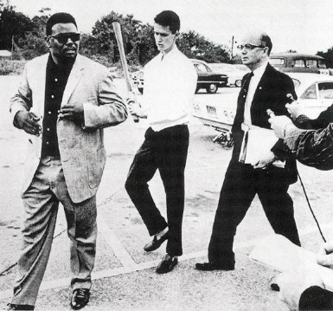
After the success of the Montgomery Bus Boycott in 1955, civil rights leaders in other southern cities sought to challenge segregation laws. One of the cities selected was Albany, in southwest Georgia. Starting in the fall of 1961, members of SNCC and the local community began to protest the segregationist policies of the city by attempting to overcrowd and flood the jails. Massive resistance from whites and the police department led to over 500 protesters landing in jail. In turn, police Chief Laurie Pritchett used non-violent tactics to arrest, but not harm the protestors. To draw more national attention to the cause, the SNCC invited Martin Luther King, Jr. to take part in the protest. Though arrested many times, King was released from jail almost immediately (though against his will). Chief Pritchett also made sure he had enough room to imprison all the protestors and worked with other counties to send the demonstrators to their jails as well. In the end, most of the protestors were jailed leaving very few to protest. By the summer of 1962, King viewed the Albany Movement as a failed attempt to desegregate an entire community, but a valuable learning experience. He used what he learned, including the power of protest songs, in his successful Birmingham campaigns.

The March on Washington
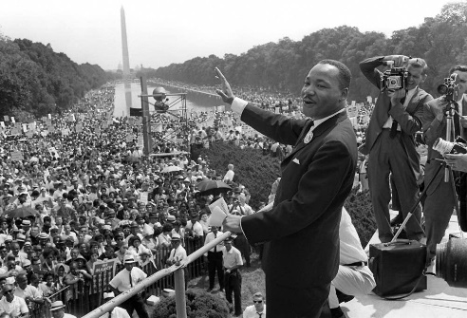
In 1963, over 250,000 civil rights activists gathered in Washington D.C. to promote their cause and push for civil rights legislation. During the March on Washington for Jobs and Freedom, Martin Luther King, Jr. gave what is arguably his most famous speech: “I Have a Dream.” The March on Washington encouraged the passage of the Civil Rights Acts of 1964 and The Voting Rights Act of 1965, and made King the most well-known spokesperson of the Civil Rights Movement.

Civil Rights Act of 1965
Encouraged by the March on Washington, the U.S. Congress passed the Civil Rights Act of 1964. This bill was signed into law by President Lyndon B. Johnson. The Civil Rights Act of 1964 forbade discrimination on the basis of sex and race in hiring, promoting, and firing.

Lester Maddox
Southern Congressional Democrats, led by Senator Richard Russell, strongly opposed the passage of the Civil Rights Act of 1965. The Republican Party welcomed segregationists who no longer felt comfortable in the Democratic Party. Some segregationists were determined to ignore the new law and responded with physical violence. It was during this period of great social and political change in Georgia that future governor, Lester Maddox (1915-2003), gained notoriety for his strong, unshakeable segregationist stand.
In 1947, he opened the Pickrick Cafeteria near the campus of Georgia Tech. Maddox’s restaurant was open only to white customers. Maddox refused to serve African-Americans and anyone who suggested integration. His restaurant featured segregationist literature and a wishing well labeled “Make a Wish for Segregation.” Maddox gained fame throughout Georgia due to his advertisements for the restaurant that he placed in the Atlanta Journal newspaper. His open defiance of the Civil Rights Act of 1964 caused him national exposure. One time, he chased three African-Americans out of his restaurant with a gun. Later, he was known throughout the nation for his use of ax handles (“Pickrick drumsticks”) to forcefully remove African-Americans who tried to integrate his restaurant. Maddox temporarily closed the Pickrick and later opened it as the Lester Maddox Cafeteria, claiming that he was not in contempt of court because he would serve “acceptable Georgians”, but not out-of-state travelers or integrationists. When the courts upheld the Civil Rights Act, Maddox was found in contempt of court due to his refusal to serve African-Americans. He was fined $200 per day, and two months later, he closed the cafeteria rather than allow it to be integrated. Even though Maddox was defeated several times running for different political positions, he was able to gain the Governor’s seat in 1966. Maddox was the last overtly segregationist governor in the state’s history. Ironically, he appointed more African-Americans to government positions than all prior Georgia governors combined. Nonetheless, Maddox was criticized for not allowing flags at state buildings to be flown at half-mast after the death of Martin Luther King, Jr., and for his fight against the civil rights platform of the Democratic Party at their 1968 National Convention. After his term as Governor was over, Maddox ran for Lieutenant Governor, and won. Throughout his life, he never apologized for his defense of segregation.

