a. Locate Georgia in relation to region, nation, continent, and hemispheres
b. Distinguish among the five geographic regions of Georgia in terms of location, climate, agriculture, and economic contributions.
c. Locate key physical features of Georgia and explain their importance; include the Fall Line, Okefenokee Swamp, Appalachian Mountains, Chattahoochee and Savannah Rivers, and barrier islands
d. Analyze the importance of water in Georgia’s historical development and economic growth
SS8G1 Describe Georgia’s geography and climate
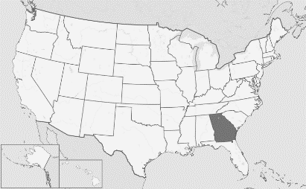
The state of Georgia is in the southeastern United States. It is located on the continent of North America, and it is in the Northern (latitude) and Western (longitude) Hemispheres.
Regions
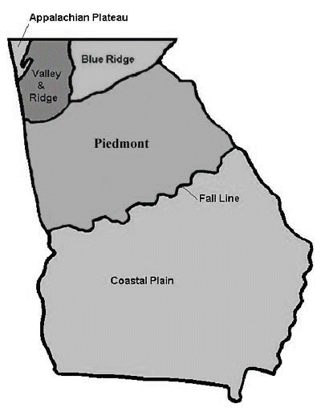
The state of Georgia is divided into five geographic regions. In the north, there are three small mountainous regions, each with a differing topography (shape and features of land surfaces). In the middle of the state is the hilly Piedmont area which is home to many of Georgia’s largest cities including Atlanta. Finally, the state is dominated by the Coastal Plain region, which takes up three-fifths of Georgia. The Coastal Plain was actually covered by water millions of years ago.

Features
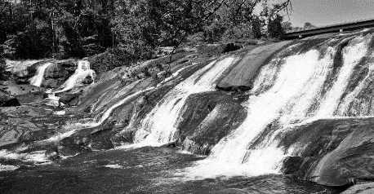
The Fall Line is a natural boundary (a wide zone) that separates the Piedmont and the Coastal Plain regions. Due to the drop-off of the hilly Piedmont region into the flat Coastal Plain, the waterfalls found on the Fall Line cause many rivers in the area to be difficult to navigate. In the past, waterfalls offered sources of water to create power so many mills were eventually located on the fall line. Early settlers off-loaded goods at these points and settled in the area, creating towns that developed into cities that populate the Fall Line region today.

The Okefenokee Swamp covers 700 square miles and is the largest freshwater swamp in North America. American Indians lived in the swamp. The Choctaw American Indians gave the swamp its name which means “land of the trembling earth”. White families began settling in the area in 1805. From 1910 until 1937, before Franklin Roosevelt established 80% of the Okefenokee as a wildlife refuge, the swamp was a major source of timber. As one of the world’s largest intact fresh water ecosystems, the swamp provides habitats to threatened and endangered species. Those species are now protected by the federal government. Another importance relates to human activity. Over 30 employees maintain this natural region to ensure that the 40,000 yearly visitors leave the habitat as natural as possible.
The Appalachian Mountains are located in north Georgia. The southernmost point of the mountain range forms the high peaks found in the Appalachian Plateau, Valley and Ridge, and Blue Ridge regions of the state. In the southern states, these mountains are called the Blue Ridge due to the blue haze that appears around their peaks. The highest peak in Georgia is Brasstown Bald, which has an elevation of over 4700 feet above sea level. The Appalachian Mountains are important because they lie in the path of moist, warm air currents from the Gulf of Mexico that produce heavy rain in the spring and summer and snow in the winter. Another importance is the tourism industry that has developed in the region due to the scenic terrain.
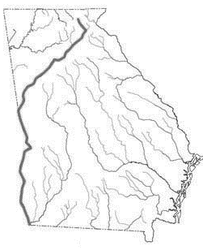
The Chattahoochee River runs from the Blue Ridge region to the Gulf of Mexico and forms part of the border between Alabama and Georgia. American Indians long used the river as a food and water source, as did Georgia’s European settlers. Today, the Chattahoochee is used primarily as a water source for the millions of Georgians living in the Piedmont area, though the river is also used for industry and recreation as well.
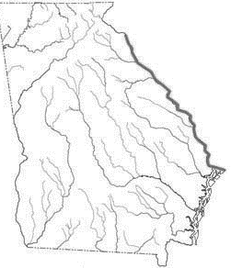
The Savannah River forms the border between Georgia and South Carolina. One of Georgia’s longest waterways, the Savannah River, flows to the Atlantic Ocean. The river has been a source of water, food, and transportation for thousands of years. American Indians lived around the river and Spanish explorer Hernando De Soto was the first European to cross it. James Oglethorpe chose a site 18 miles upriver to create Georgia’s first city, Savannah. Today, the river is navigable for over 200 miles between the city of Savannah and Augusta. In addition to shipping, the river is used as a major source of drinking water for Savannah and Augusta, to cool nuclear power plants in Georgia and South Carolina, and to generate hydroelectric power. Other uses include irrigation for agricultural crops and recreation.
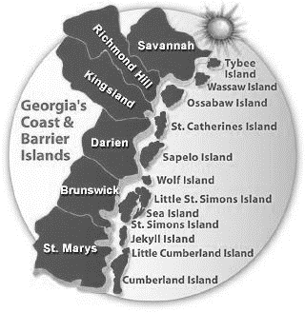
The Barrier Islands are a chain of sandy islands off the coastline of Georgia. These islands protect the mainland from wind and water erosion. There are 14 Barrier Islands off Georgia’s coast including Tybee, St. Simons, Jekyll, and Cumberland. Some of the islands, such as Cumberland, are wildlife refuges and are national or state parks. Others, like St. Simons, have been developed and three (Little Cumberland, Little St. Simons, and St. Catherine’s) are still privately owned. People have lived on these islands for thousands of years. American Indians lived on them and, in the 1500’s, the Spanish set up missions there.
Importance of Water Sources
Water sources in Georgia have historical significance. Much of Georgia’s boundaries are bodies of water. American Indians and early settlers depended on the rivers and streams for food and transportation. As farming increased in the state, water sources were necessary to adequately serve the crops. Rivers were used to transport goods and people as the state’s population expanded into American Indian territory. Man-made lakes (reservoirs), primarily located in the northern half of the state, have benefited flood control, hydroelectricity, and have provided recreational areas for Georgians.

American Indians recognized the importance of rivers and streams to trade. These early cultures used the rivers to transport animal pelts and trinkets to other settlements for trade. Trading posts were established and, when the Europeans arrived, many settled in the areas of these posts. Before the arrival of the railroad, rivers were used to transport raw cotton to the coastal ports. Steamboats provided transportation for goods and passengers on Georgia. Factories and mills were powered by the rushing waters of Piedmont Georgia. Georgia’s Savannah and Brunswick ports were important as they built ships for World War II. The ports today are among the most successful of the Eastern seaboard ports for imports and exports.
